Question 1:
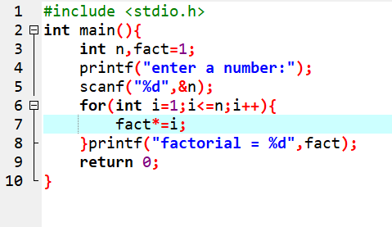
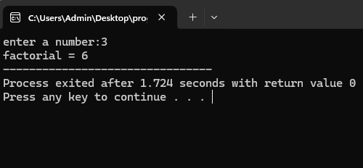
Question 2:
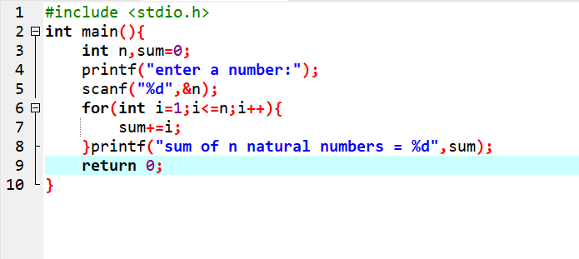

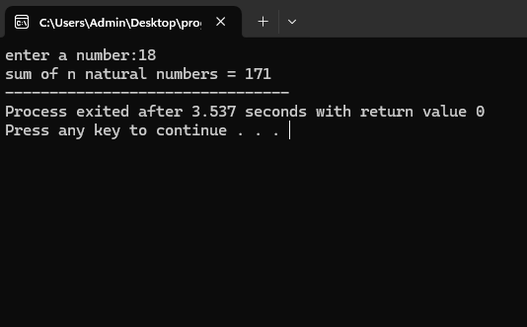

Question 3:
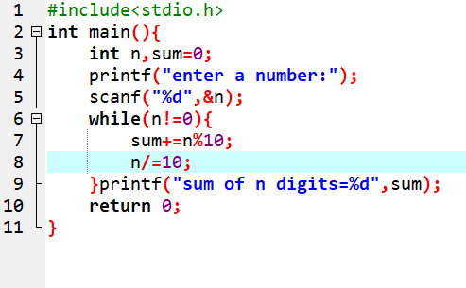

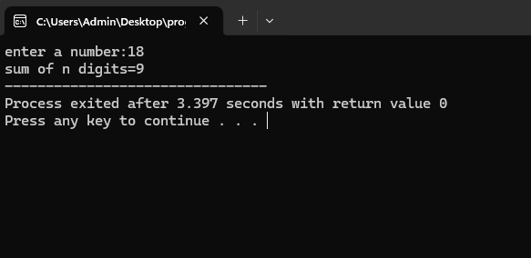

Question 4:
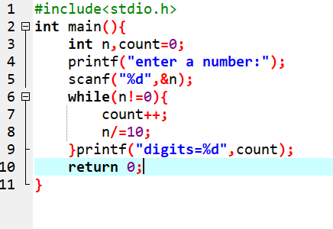
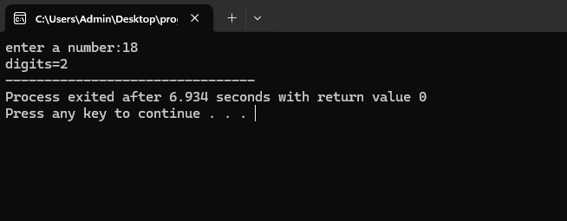

Question 5:
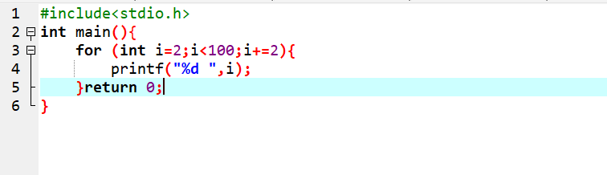
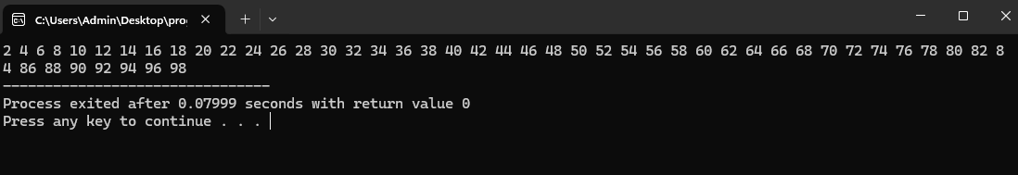
Question 6: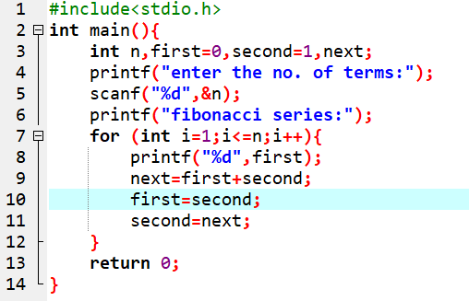

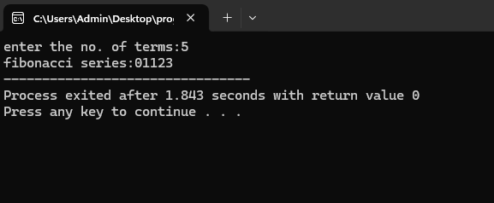
Question 7: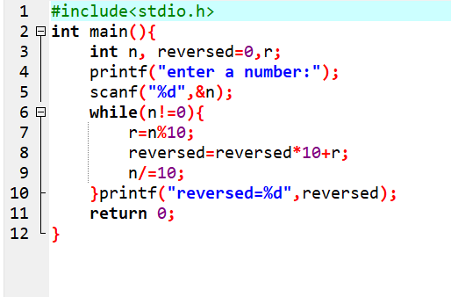

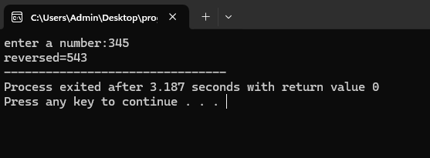
Question 8: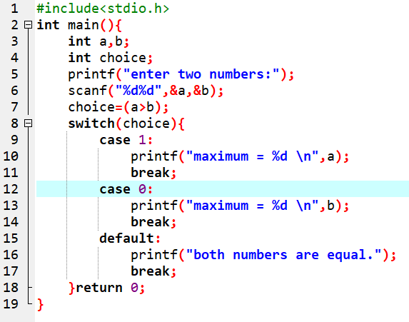

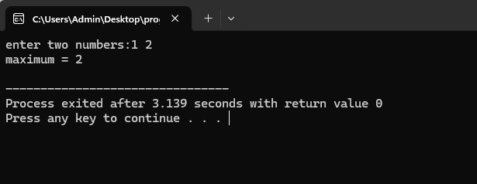
Question 9: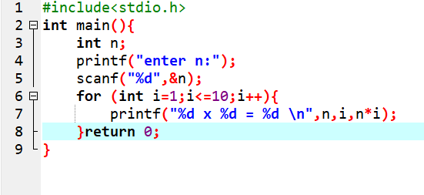

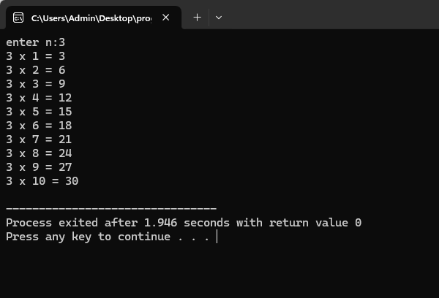

Question 10:

#include <stdio.h>

int main() {
int choice;
float num1, num2, result;

printf("Enter two numbers: ");
scanf("%f %f", &num1, &num2);

printf("\nChoose an operation:\n");
printf("1. Addition (+)\n");
printf("2. Subtraction (-)\n");
printf("3. Multiplication (*)\n");
printf("4. Division (/)\n");
printf("Enter your choice (1-4): ");
scanf("%d", &choice);

switch (choice) {
case 1:
result = num1 + num2;
printf("Result: %.2f\n", result);
break;

case 2:
result = num1 - num2;
printf("Result: %.2f\n", result);
break;

case 3:
result = num1 * num2;
printf("Result: %.2f\n", result);
break;

case 4:
if (num2 != 0)
result = num1 / num2;
else {
printf("Division by zero!\n");
return 0;
}
printf("Result: %.2f\n", result);
break;

default:
printf("Invalid choice!\n");
}

return 0;
}
